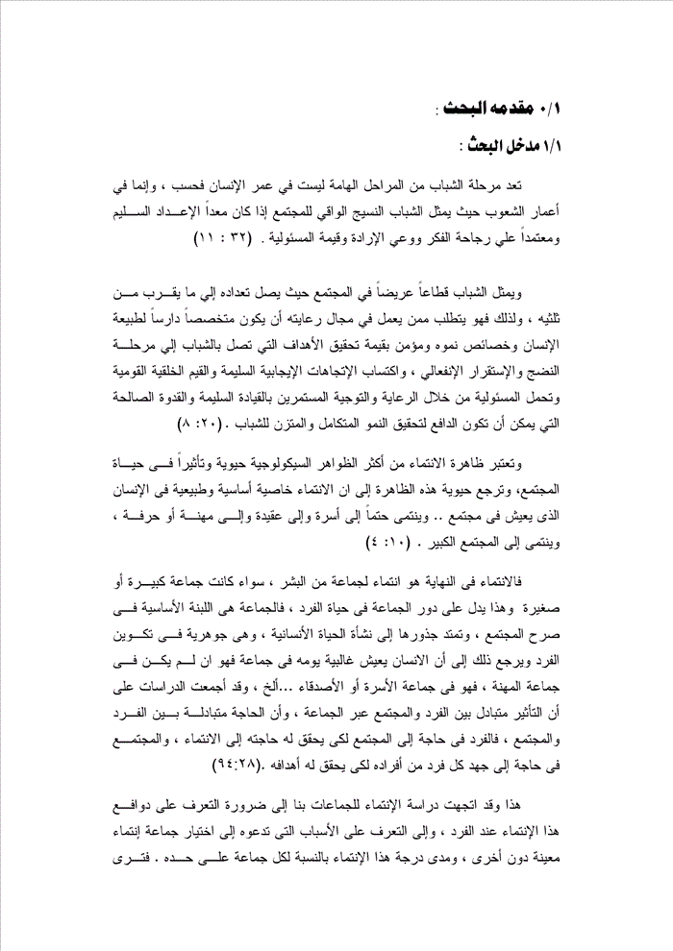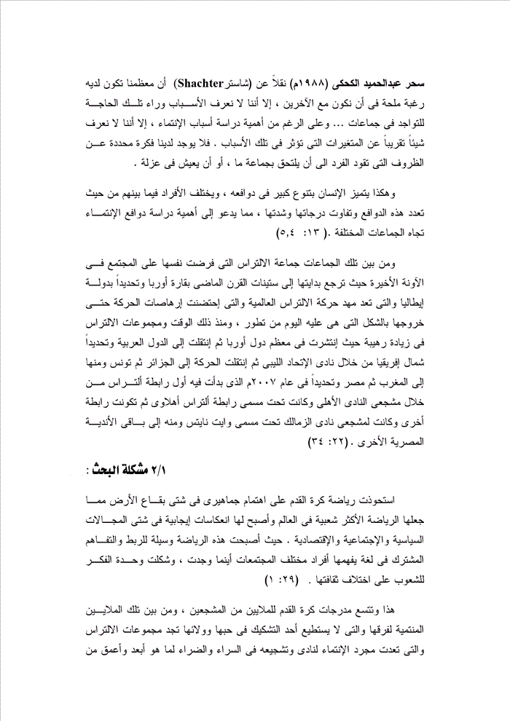

Introduction and research problem
The stages of young adulthood is not important in human life , but in the age where a young peoples protective fabric of the society if it is set up proper setup and relying on the wisdom of thought and awareness of the value of the will and responsibility.
And represents a broad cross-section of young people in the community where the population of up to nearly two-thirds . Therefore it requires of those who work in the field of sponsorship to be dedicated student of human nature and the characteristics of growth and insured value of achieving goals that link youth to maturity , stability, emotional , and gain positive trends sound and moral values of nationalism and take responsibility through the care and guidance of ongoing leadership, sound and good example that can be be motivated to achieve an integrated and balanced growth of young people.
The phenomenon of belonging of the most phenomena psychological vital and influential in the life of society , and returns the vitality of this phenomenon to the affiliation property essential and natural in humans who live in the community .. and belongs inevitably to the family and to the doctrine and to the profession or craft , and belongs to the community at large.
Affiliation in the end is the affiliation to a group of human beings , whether they are a large group or small, this indicates that the role of the community in the life of the individual , The community is the basic building block in the edifice of society, rooted in the emergence of human life , which is essential in the formation of an individual is due to the fact that human lives the majority of his day in the group is that the group was not in the profession , he is in a group of family or friends ... etc. , have been studies agree that the mutual influence between the individual and society across the group , and that the need for correlation between the individual and society , the individual in need of the society in order to achieve his need to belong . The society is in need of every individual effort of its members in order to achieve his goals.
The study of belonging to groups tended us to the need to identify the motives of this affiliation when an individual , and to identify the reasons that invites him to choose a particular group affiliation without the other , and the degree of this affiliation for each group separately .
Ferry ( Schuster (Shachter , citing charm Hameed ElKahky ( 1988 ) that most of us have had an urgent desire to be with others , but we do not know the reasons behind the need for the presence in groups ... and in spite of the importance of studying the causes of belonging, but we do not we know almost nothing about the variables that affect those reasons. do not we have a definite idea about the circumstances that lead an individual to join the group , or to live in isolation .
Thus characterized by great diversity in human motives , and different individuals with each other in terms of the multiplicity of these motives and varying degrees and intensity. Which calls for the importance of studying the motives of belonging to different groups
Among those groups, group ultras , which imposed itself on the community in recent where returns start to Satinat last century the continent of Europe and specifically the state of Italy, which is the cradle of the movement of ultras world and that has embraced the harbingers of movement until it exits in the form that it is today of evolution , and since that time, and the ultra groups in a dramatic increase since spread to most countries in Europe and then moved to the Arab countries , specifically North Africa through Al Ittihad of Libya and then moved movement to Algeria and Tunisia, and from there to Morocco and Egypt , and specifically in the year 2007 , which began when the first Association of Ultras by fans of Al-Ahli and was under the name of the Association of Ultras Ahlawy then formed another association was for fans Zamalek Club under the name of White Knights and the rest of it to other Egyptian clubs. I enter the young ultras a new form of encouragement in football stadiums , most of them university students , schools , and representing different social strata , where it was initially with links fans , then took control of their principles and thought ultras , and spread their communities , and is adorned with terraces Boloanam delightful , and Bdkhalathm which is called ” Altyvo ” It is football mad , as he calls the Italians and Spaniards.
But soon with altered positive image for links ultras have become troubled because of the congestion , which ended in disaster match the Club El Masry Club and Al-Ahly in early February of 2012 , which killed 74 people, fans of Al-Ahly , and wonder what proved the merits of the court’s ruling in this case , where has shown that the real culprit he thought ultras itself , which is built on the translation links Ultras Egyptian club in the incident , and did not stop at corners football stadiums not received housings and important installations from the oppression of those fanatics who Grthm so many of the time gathering due to the presence of common features , including them as a sense of danger one man in knows the collective mind..

